Trader Interface Testing (PHP)

Table of Content

1. Register

1. Register with password and confirm password incorrect
2. Register with invalid password format
3. Register with email that is already registered
4. Register with shop type that is already registered
5. Register with correct credentials

2. Verify

1. Activate account with verification link sent in email of trader

3. Login

1. Login with incorrect email
2. Login with incorrect password
3. Login with correct email and password

4. Reset Password

1. Clicked on reset password link to send email verification for reset password
2. Click on link to reset pass

5. Trader Interface

1. View Products
2. Add Products
3. Update Products
4. Delete Products
5. View Profile
6. Update Profile
7. View Report

6. Logout

1. Logout of the trader from trader page

# Register

1. Register with password and confirm password incorrect

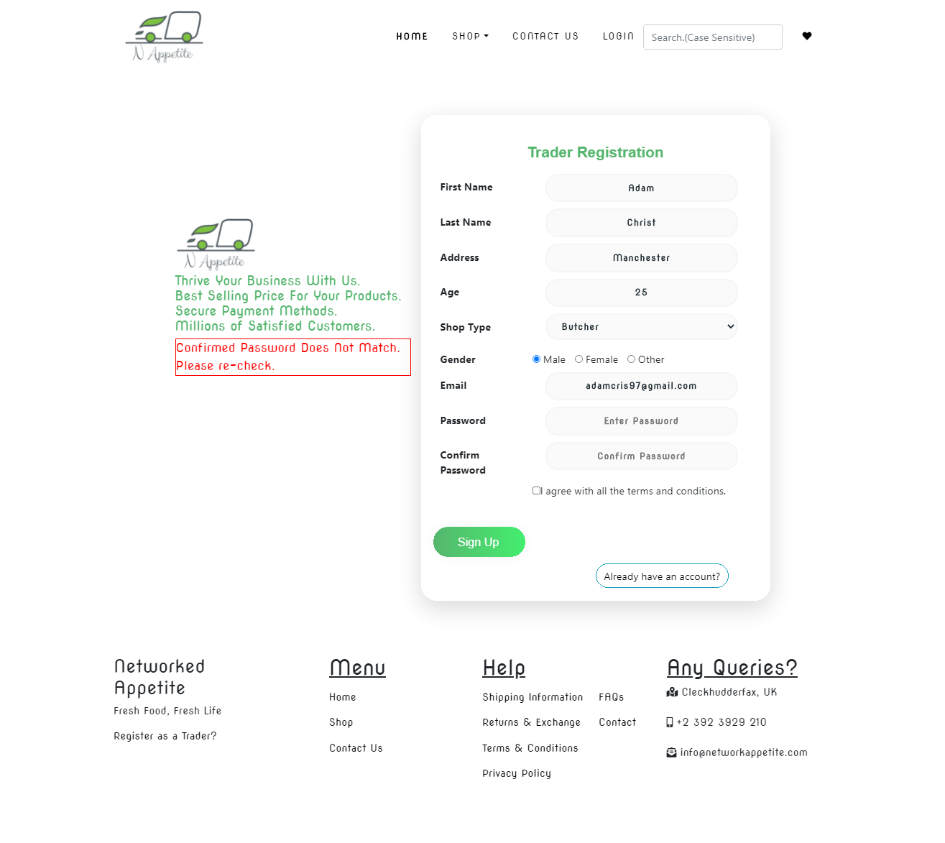

If trader tries to register with unmatched password and confirm password field, then registration fails and an error message is shown.

1. Register with invalid password format

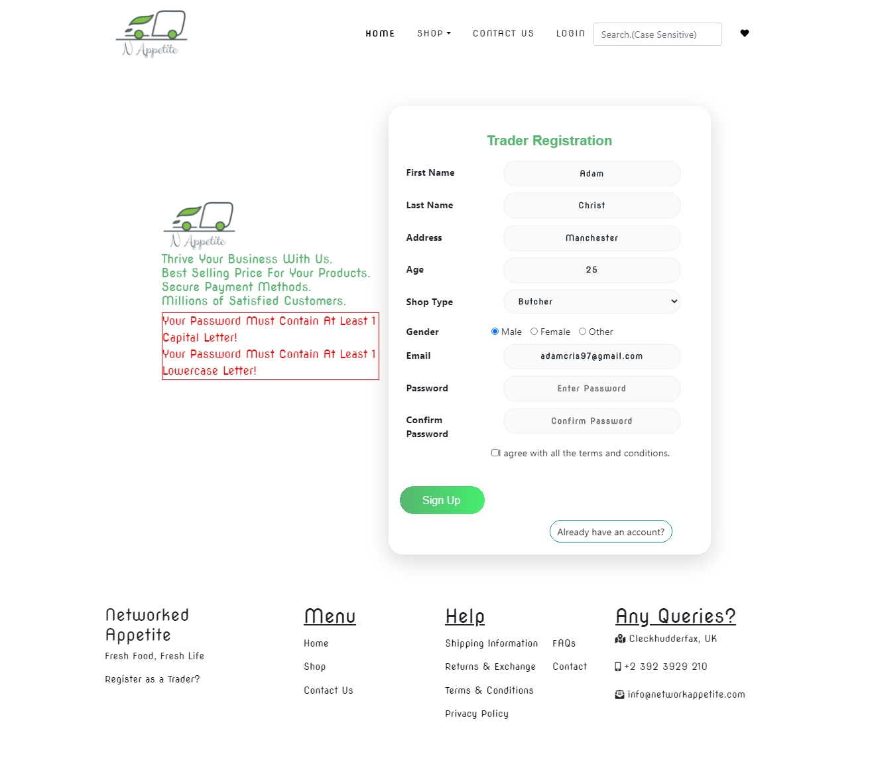

If trader tries to register with incorrect password format, then registration fails and an error message is shown.

//TESTING WITH EMAIL AND TRADER TYPE ALREADY REGISTERED

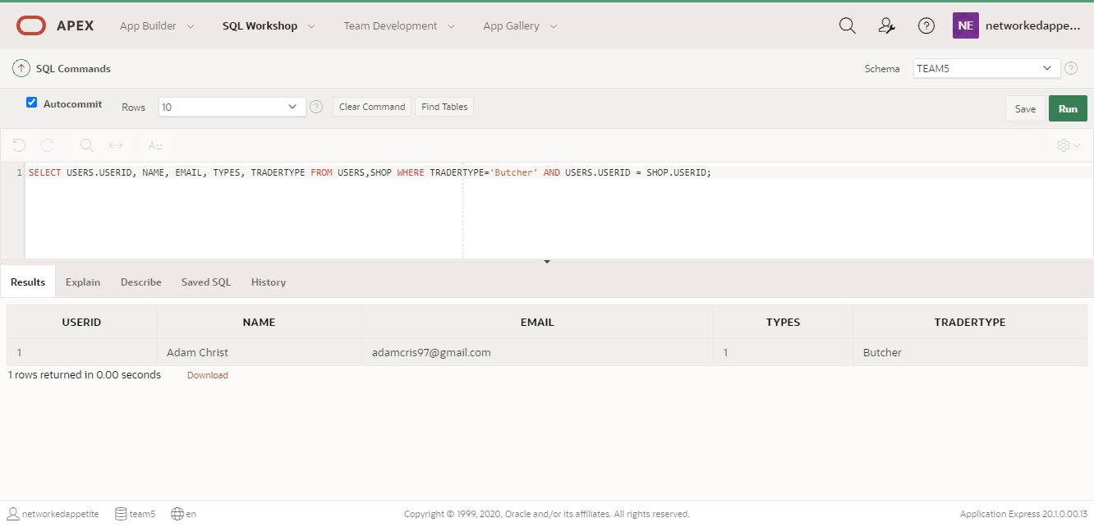

As shown above we already have email and trader type registered. So trying to register with same email or trader type will result in registration failure with respective error message.

1. Registering with email that is already registered

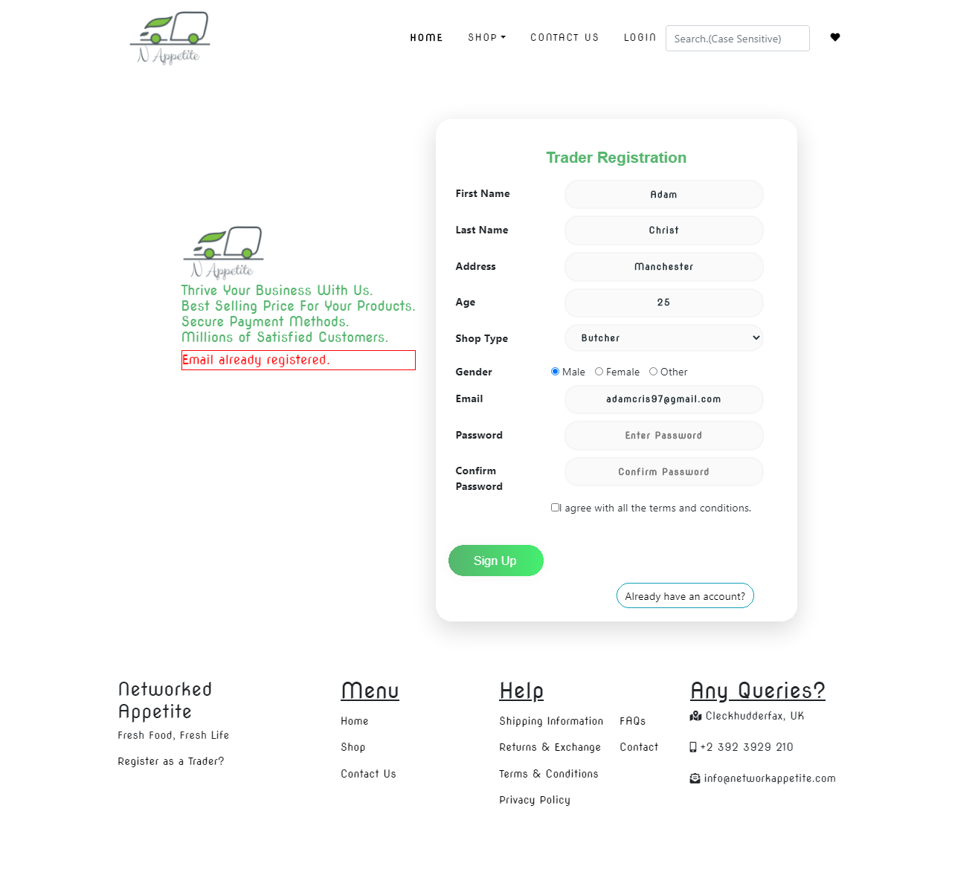

Registration fails and an error message is displayed.

1. Register with shop type that is already registered

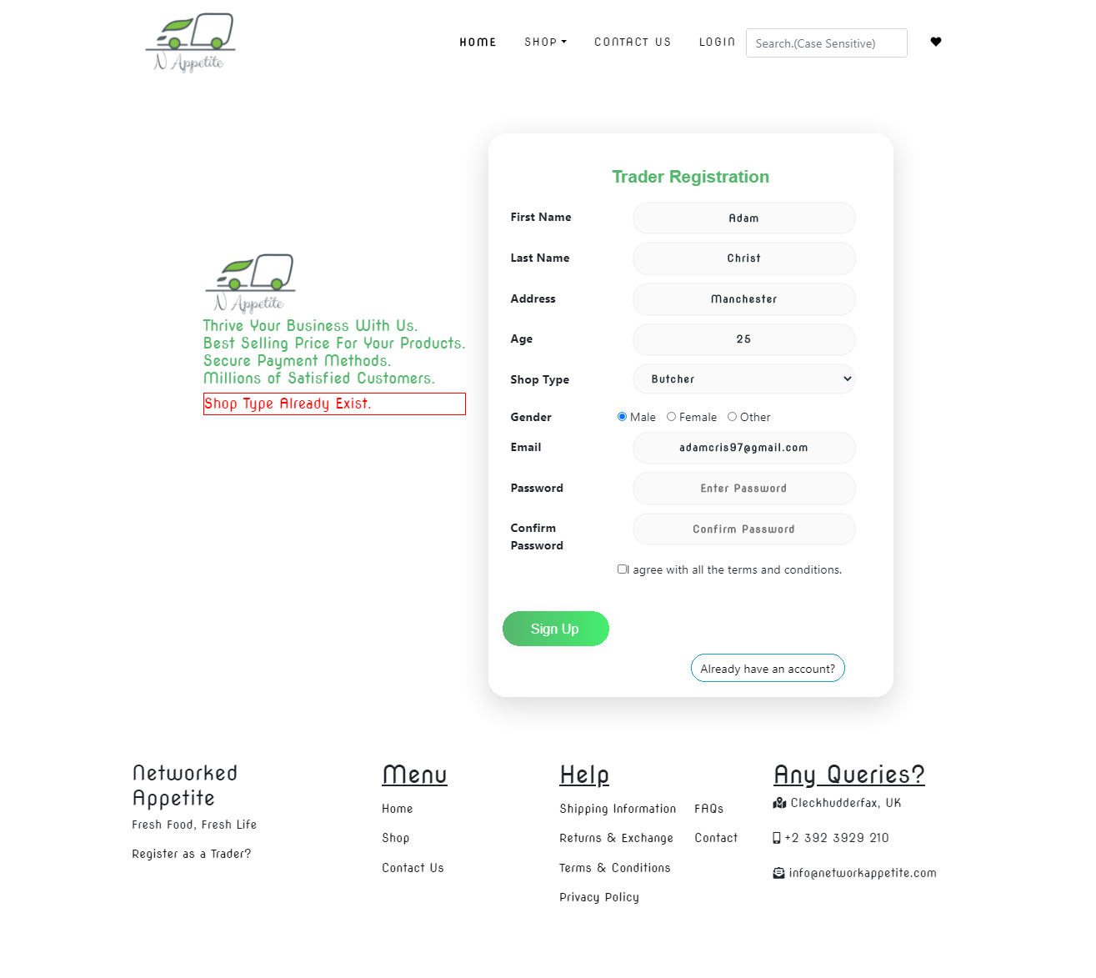

Registration fails and an error message is shown.

1. Register with correct credentials

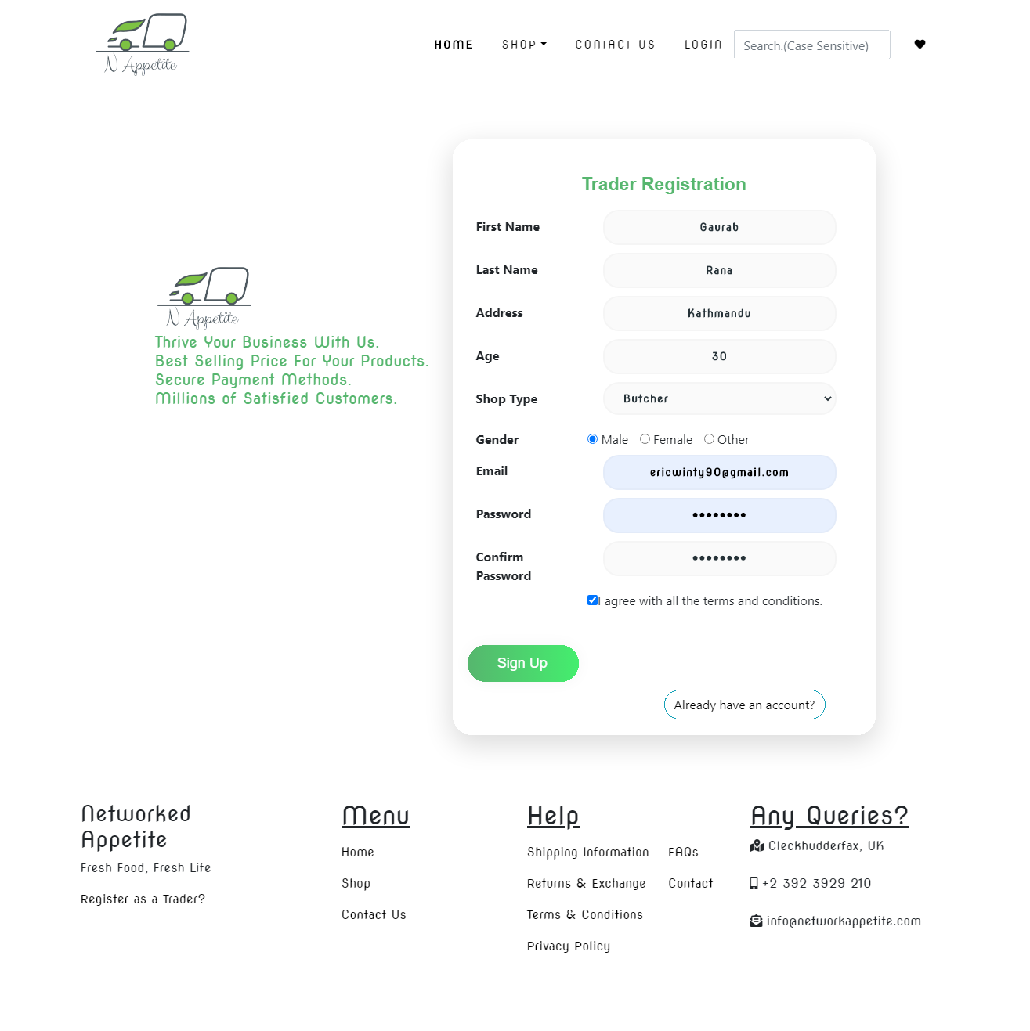

Registration with correct info and an email is sent to the email of user.

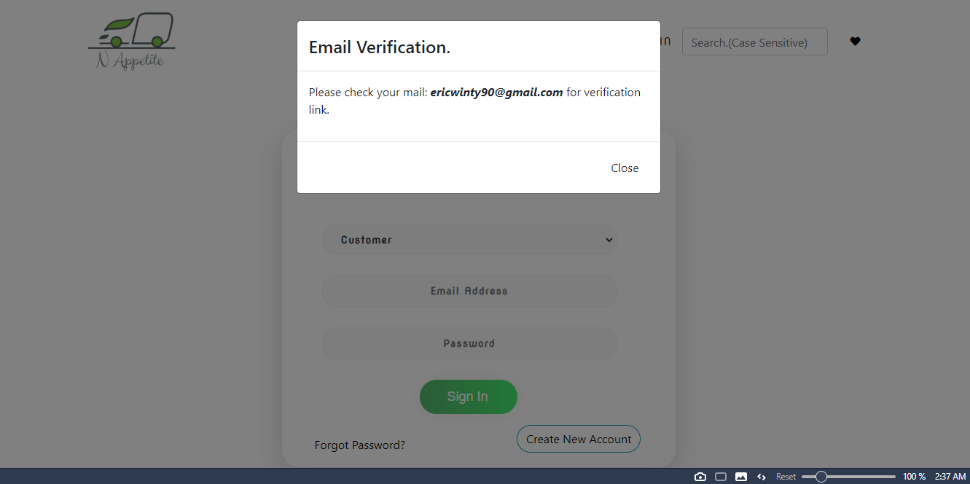

# VERIFY USER

1. Clicked on activate account in email to verify email



Clicking on activate account will redirect trader this page below.

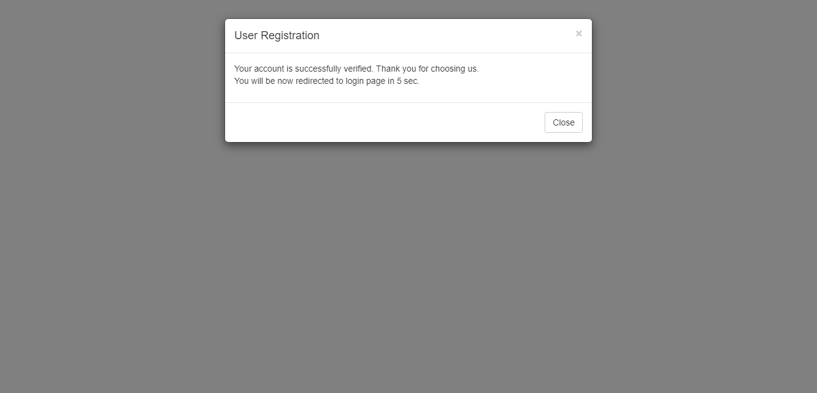

User is verified and redirected to login page. Then trader can login.

# Login

1. Tried logging in with incorrect email

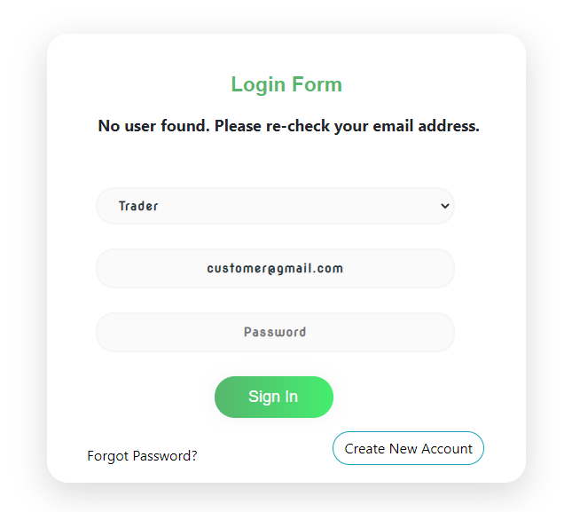

Login fails with an error message ‘no user found’.

2. Tried logging in with incorrect password

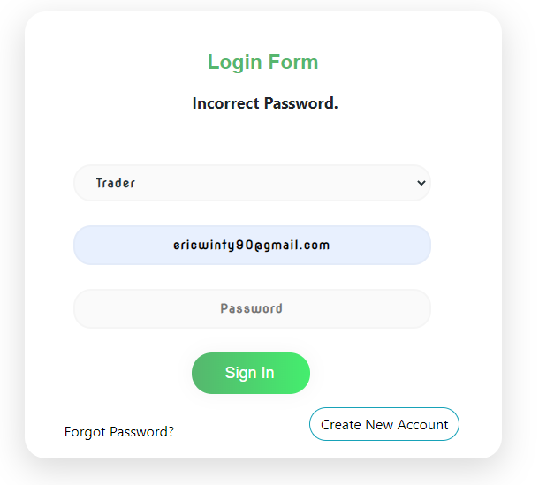

Login fails with an error message ‘Incorrect Password’

3. Tried logging in with correct email and password

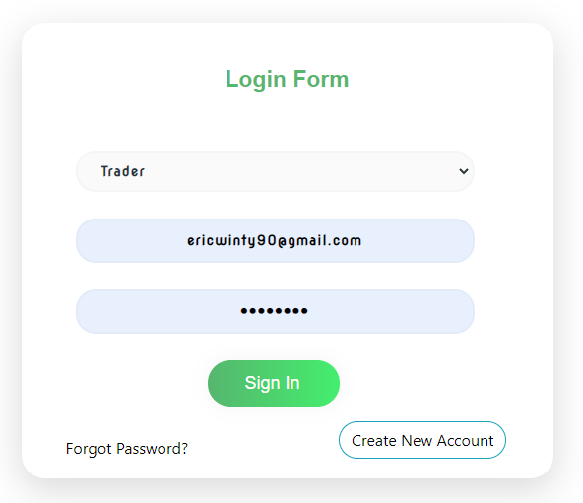

Login is successful and trader is redirected to trader interface.

# Reset Password

1. Clicked on reset password to send email verification link to reset password

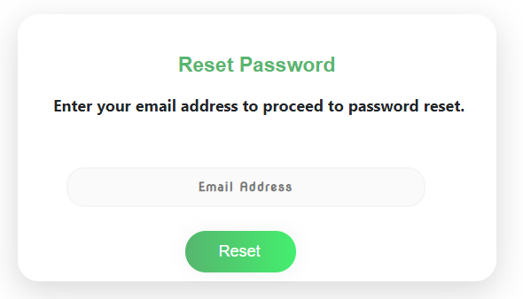

Traders enter their mail and click on reset. An email was sent with verification link.

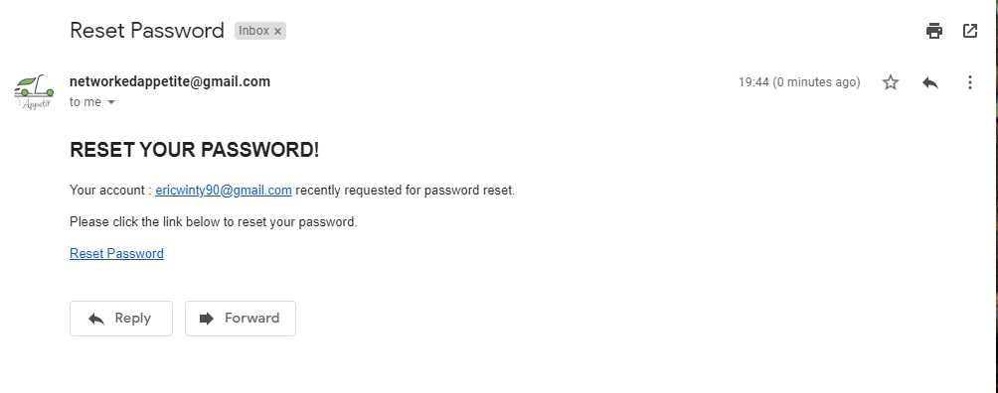

Clicking on reset password took trader to reset page. The page checks password validation as well.

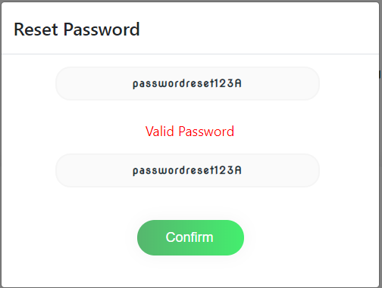

After confirm password was reset trader was redirected to login page with an message.

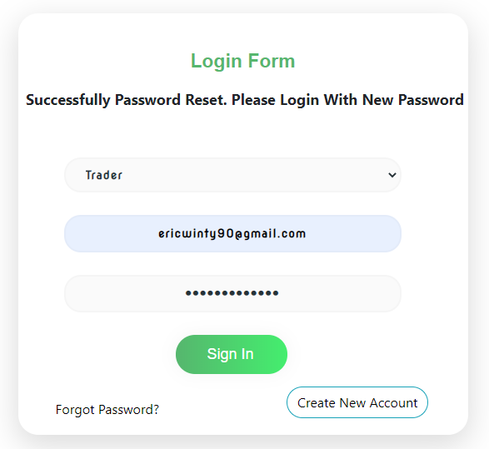

# Trader Interface

1. View Product

This is the trader interface where product list are shown once they are added.

# D:\Project Management\4.Monitoring and Controlling\Testing and Evaluation\Trader (Php)\Trader Product Interface.png

1. Add Product

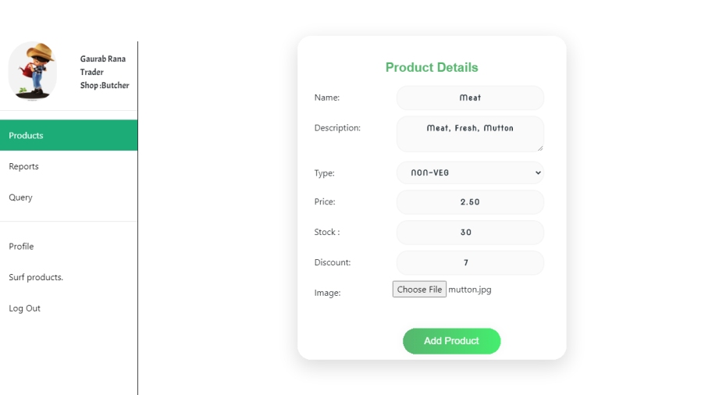

Trader can add product in this manner.

1. Update product

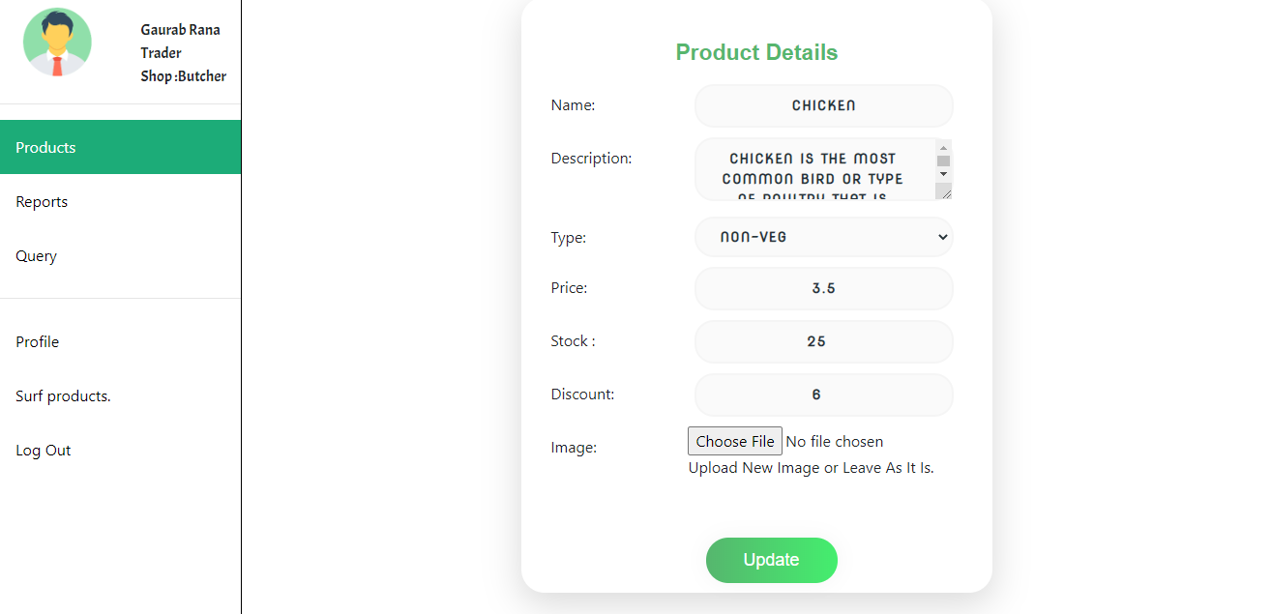

1. Delete Product 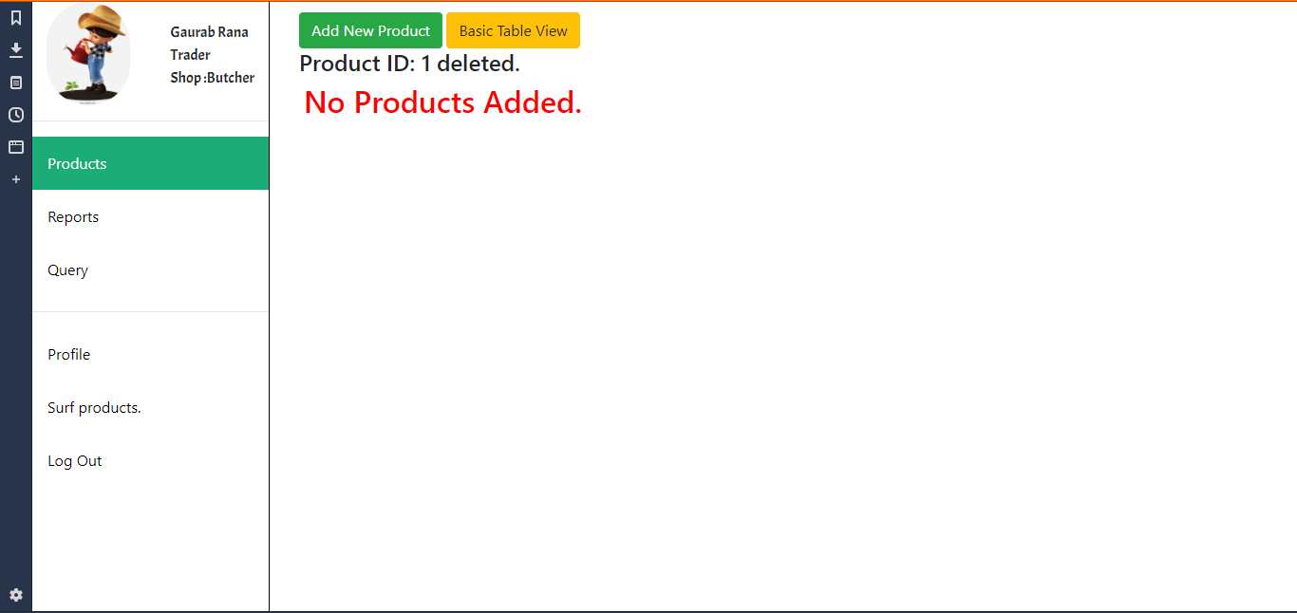

Product deleted successfully

1. View Profile

Profile of trader shown successfully

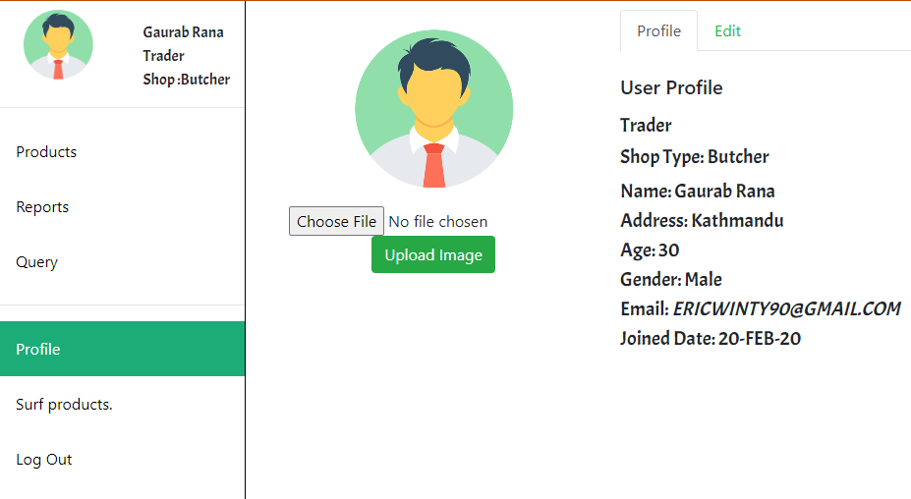

1. Update profile.

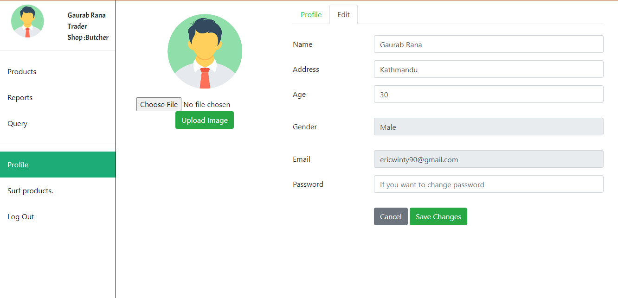

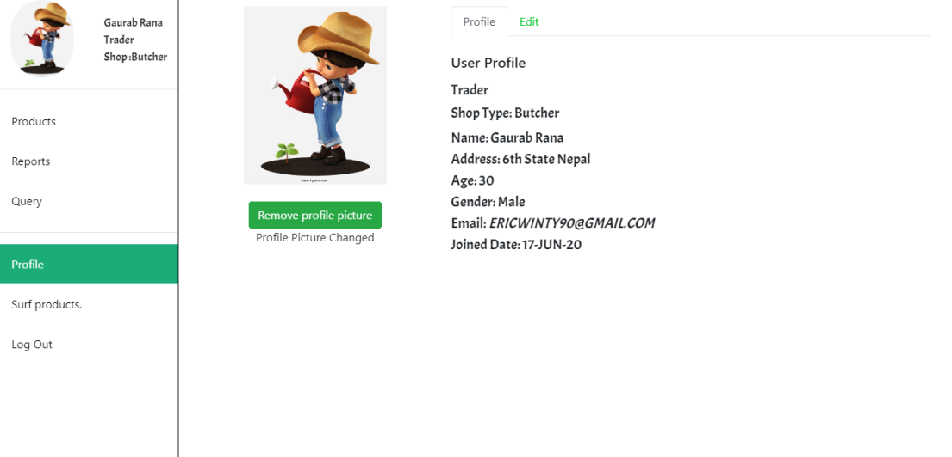

Profile updated successfully

1. View Report

On click reports trader is redirected to oracle application.

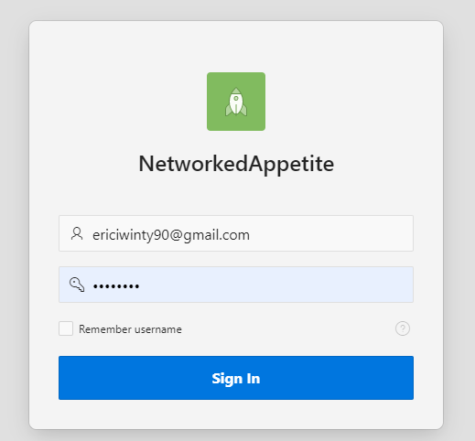

# Logout

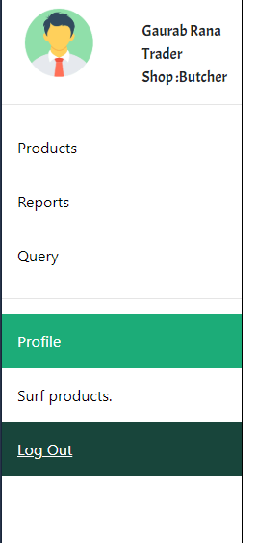

Traders can logout from the page using Log Out button at the bottom of the page.